Dear, Kezia

Happy Valentine’s Day Kez! Although we are very far away and we’re still technically Boy-Friend and Girl-Friend. I figured to just make this small website for fun ha-ha soalnya kan German juga bakal ada javascript!

If you really ask me, I think I am still scarred from the breakup Kez. I know it’s been 2 months but if I be honest, it still stings when you left me. I know you have your reasons and how our situation was.

TBH, I just lebih hesitant and want to keep it friendly as I am not ready for a serious relationship with anyone even you. I know that you also say that you let people text you, but you don’t feel anything but maybe it’s because of us missing each other that got in the way. I don’t want to be in a relationship because I really poured all my love to you before, it’s just hard to love like that again and I don’t want to force you to wait for anything if I’m still hesitant like this, it would be like selfishly keeping you around. As you are ready to have a serious relationship for marriage and its unfair if I’m still hesitant like this.

I know I was good to you (most of the time ☹) but that doesn’t mean there are no other people like me. You said that it is a form of love to let go of someone, to be honest, it is true, but the breakup was from you not feeling anything for me anymore and that left me questioning our relationship. I still love you Kezi boo, I want to kiss you, hang out with you, cuddle and love you, but these are what I truly feel. If I keep you in the dark about it, I don’t think I could ever forgive myself. I’m still held back by the past.

Sorry for tiba2 being blunt. This is what I feel Kez, I know I flirted with you like crazy. I really do miss you bunchies. BUT, when I was still your boyfriend, I had planned on camping with you here for a while, but it was scrapped because well EHEM. I was planning to do it on this feb 14 sadly if we were still together. Maybe you can go with your friends instead HAHA

Hammocks By The River

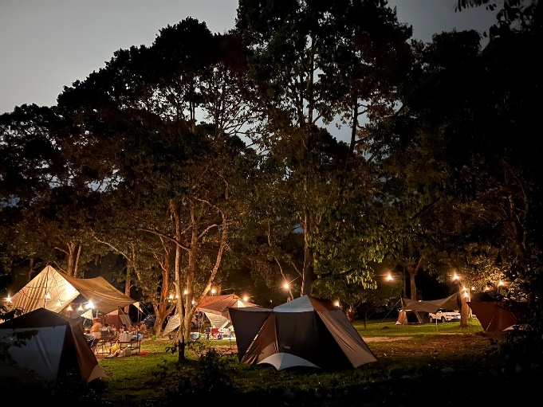

Here We can truly become one with nature HAHA! We would have a picnic! Go SUNSET VIEW, Hike around the area! Nap beside the riverside using the hammock, COOK KBBQ, STARGAZING! SWIMMING! Finally Cuddle haha! Wished we had done this sooner :<

Happy Valentines Kez! Sorry for giving you like a roller coaster of emotions in this letter

Love, Bryan